Tony Hong

1005109482

Oct. 7, 2020

CSC258 Prelab (Lab 3)

**Part 1: Splitter + 7-to-1 MUX**

1. Below is a schematic on how I designed the circuit that splits a multi-bit input to provide inputs to a 7to1 MUX.



**b.** The total size of the multi-bit input that would provide all the inputs to the 7-to-1 multiplexer would theoretically be 10 bits. 7 of the bits would feed the 7 non-select inputs of the multiplexer while the other 3 bits would feed the select input bits. In Logisim though, since a 3 select multiplexer can map 8 different inputs (2^3), therefore we would need another constant 0 input bit to fill in the last MUX input making the total number of input bits required 11.

3. Below is a screenshot of a simulation result from my test vectors for this circuit

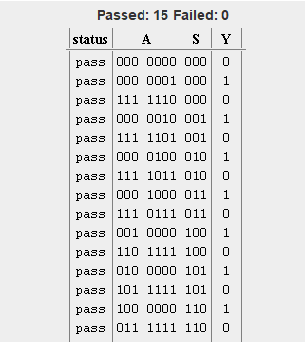

**Part 2: Ripple-Carry Adder**

1. Below is a schematic of my ripple carry adder for two 4-bit inputs.



1. Below is a screenshot of a simulation result from my test vectors for this circuit

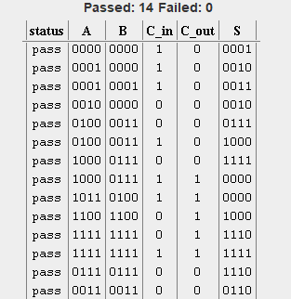

**Part 3: Basic ALU**

1. Below is a high-level schematic on how my ALU is designed with each individual function inside it’s own lower level module.



**Below are test vectors for each function the ALU supports.**

**Function 0: Adding 1 to A**

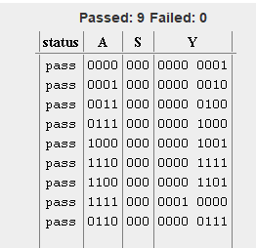

**Function 1: Adding A and B with my ripple carry adder**

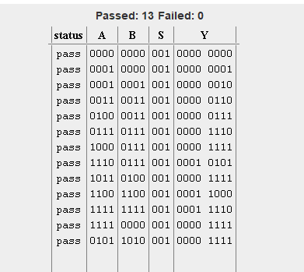

**Function 2: Adding A and B with built in adder**

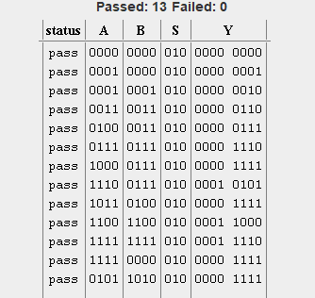

**Function 3: Bitwise A XOR B and A OR B**

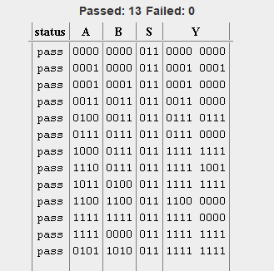

**Function 4: Reduction OR**

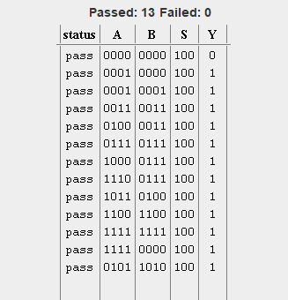

**Function 5: Display A with 4 most significant bits and display B with 4 least significant bits**

